RGossips Brand Portal

Bug & Fix Report

ID | Area | Issue & suggested fix | Where to see it (screenshot ref)
B1 | Campaigns → New Campaign | With all required fields filled, both “Save Draft” and “Publish” fire NO save request to the backend and give no success or error message. Console logs “Auth initialization timed out, forcing loading=false”, suggesting the auth token needed for the write isn’t ready.  Fix: Fix the submit handler / ensure the auth token is ready before enabling submit; on failure show a clear error and retry. This is the core brand action and must work reliably. | 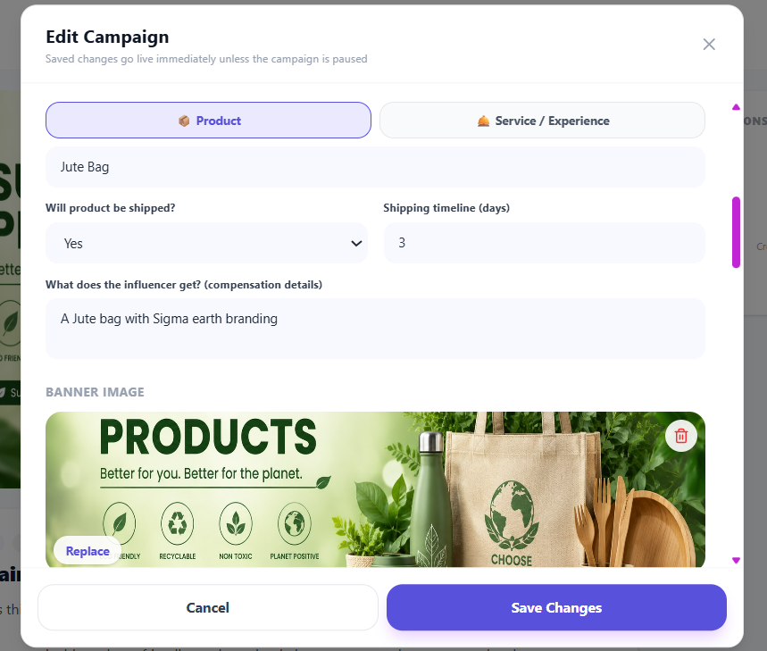
B2 | New Campaign validation | The required Schedule dates (Start, Application Deadline, Campaign End) and the “What are you promoting?” product name block submission but show NO error. Only “Title” renders an inline error, so the button appears dead.  Fix: Show inline errors on every required field, auto-scroll to the first error, and/or disable submit with a tooltip listing what’s missing. | 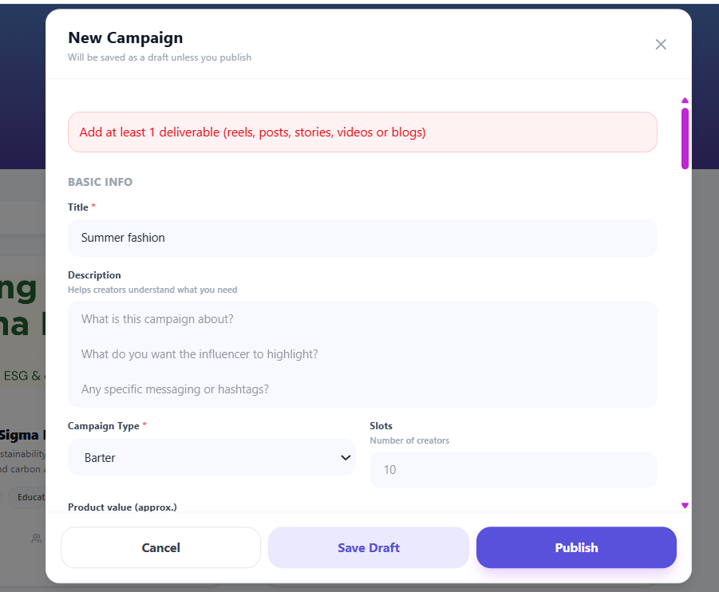
B3 | Search | Category text search returns nothing. Searching “beauty” shows only 1 influencer yet the Beauty & Skincare filter returns many creators and the placeholder promises “name, username or category.” Search matches only name/username.  Fix: Index and match categories (and ideally city/niche) in text search, or correct the placeholder. Add autocomplete. | 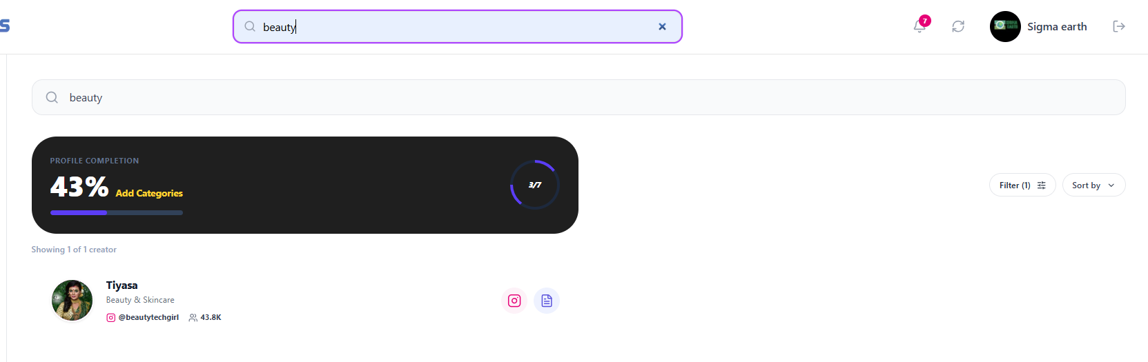
B4 | Creator card → Media Kit | The media-kit icon opens /kit/<username> which shows “Media kit not found — this media kit may have been removed or the link is invalid.”  Fix: Only show the media-kit action when a kit exists; otherwise hide it or show a different message like the user has not generated media kit yet. | 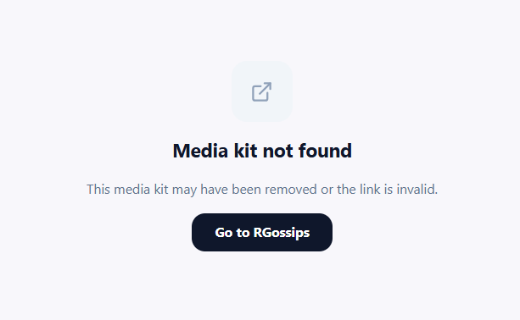
B5 | Campaigns | Expired campaign still shows “Active.” The “test” campaign deadline is 30 Jun 2026 (past; today is 1 Jul 2026) but status is ACTIVE with no expiry flag.  Fix: Auto-move past-deadline campaigns to Completed/Expired, or visibly flag overdue campaigns. | 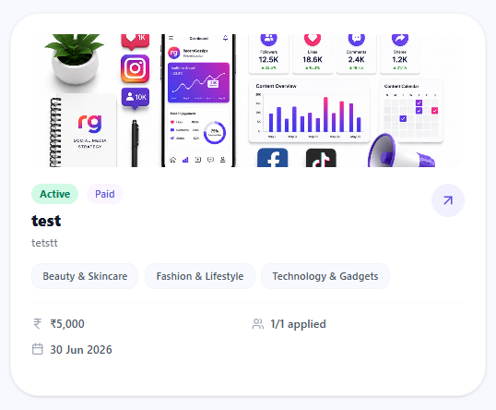
B6 | Data quality / verification | An approved applicant (“Deepak Kumar”) shows “0 followers,” and several dashboard “Top Creators” show “—” for rating. Undermines the “verified profiles” promise.  Fix: Validate/enrich creator metrics on import; hide or badge profiles with missing follower/rating data. | 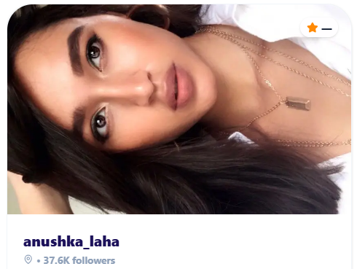
B7 | Dashboard images | Some “Recently Connected” avatar images (Google-hosted URLs) fail to load (0 natural width), showing broken/empty avatars.  Fix: Proxy/cache external avatars or show a fallback initial-avatar when the image fails. Also remove the Instagram button and show “Media Kit” button instead. | 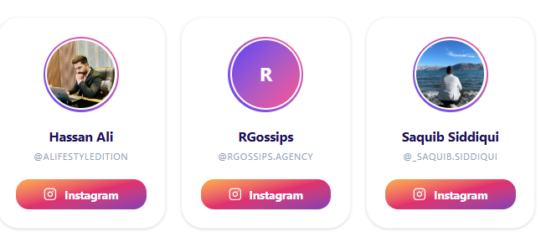
B8 | Dashboard layout | The “Beyond Influencers” section (Celebs & Actors / Publishers & Media / Talent Agencies / Meme Pages & More) renders at zero size — the heading exists in the DOM but no content is shown.  Fix: Populate the section or remove it until content is ready; fix the zero-height container. | Already Fixed
B9 | Branding | Inconsistent product name: header logo reads “recentgossips,” the app/sidebar says “RGossips,” and FAQ/marketing say “Recent Gossip” / “Recent Gossips.”  Fix: Standardise on one brand name and spelling everywhere (logo, copy, FAQ, meta). | Header logo vs sidebar vs homepage FAQ
B10 | Copy / grammar | Copy errors: dashboard “Discovery local talent right now” (should be “Discover”); campaign detail “1 REELS” (should be “1 REEL”).  Fix: Proofread microcopy; pluralise deliverable labels dynamically. | Dashboard → Creators by Location; Campaign detail
B11 | Search UX | Header search keeps a stale query (still showed “nonaberrry” across pages), and there are two separate search boxes (header + on-page) which is confusing.  Fix: Clear/sync the header query with the active view; consolidate to a single search field. | 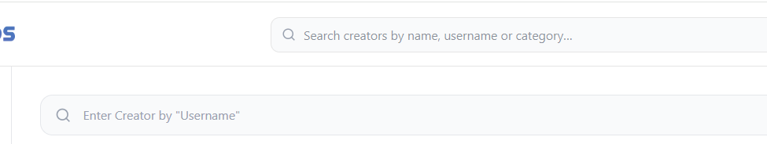
B12 | Accessibility | Modal a11y errors in console: “DialogContent requires a DialogTitle” and “Missing Description / aria-describedby.” Screen readers can’t announce dialogs properly.  Fix: Add DialogTitle + aria-describedby (or VisuallyHidden) to all dialogs. | New Campaign & Edit modals (console)
B13 | Trust score copy | Trust-score caption differs by page: dashboard “CAPPED AT 720 · 3 CAMPAIGNS TO LIFT” vs profile “CAPPED AT 720 UNTIL 3 CAMPAIGNS COMPLETE.”  Fix: Use one consistent phrasing. | Dashboard vs Profile → Trust Score
B14 | View on Instagram | Currently we are showing view on Instagram button, which is getting redirected to Instagram.  Fix: Remove this button | 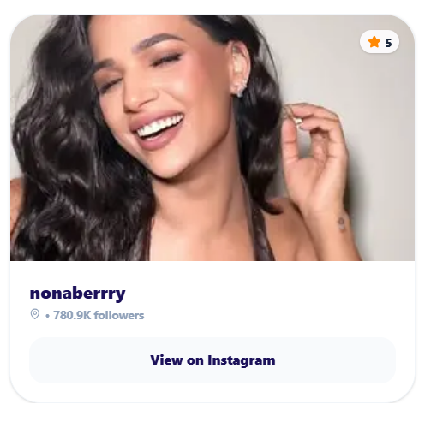
B15 | Negotiation and Campaign flow | Currently the influencer is not getting to approve the negotiated amount,  Fix: Influencer should get one chance to pitch his price and if the brand approves, then only escrow payment needs to be made by brand.  The drafts submitted and the negotiations or revisions requested are not shown in the flow as of now.  Fix: On the right hand side of the campaign details, there should be only the Influencer DP and name with status (Applied or Approved) card, once the brand clicks on that card, the whole journey should be shown with all the details. | 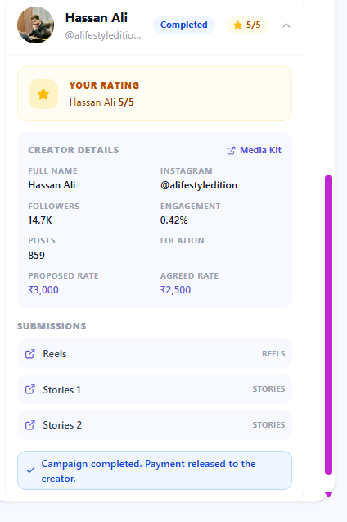

Spacing Issues:

1. The categories tabs should align with the profile completion tab on right hand side.

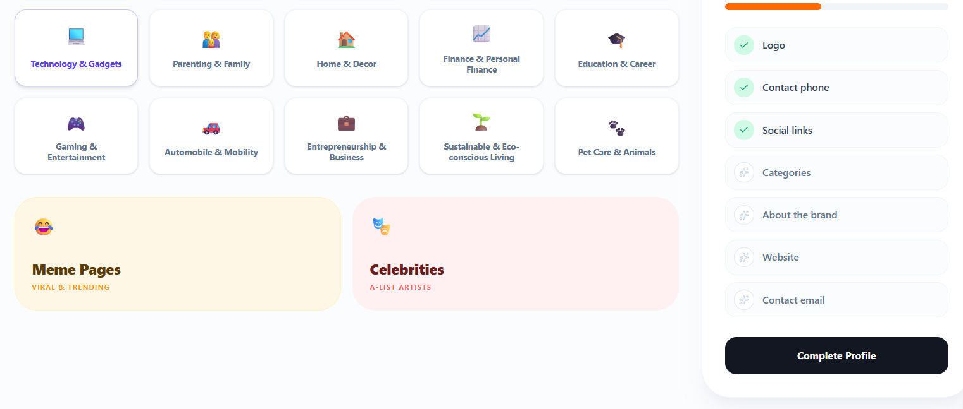

2. Spacing between all the different sections should be same. Like there is too much gap between “Influencers Recently Connected” and “Creators by Location”.

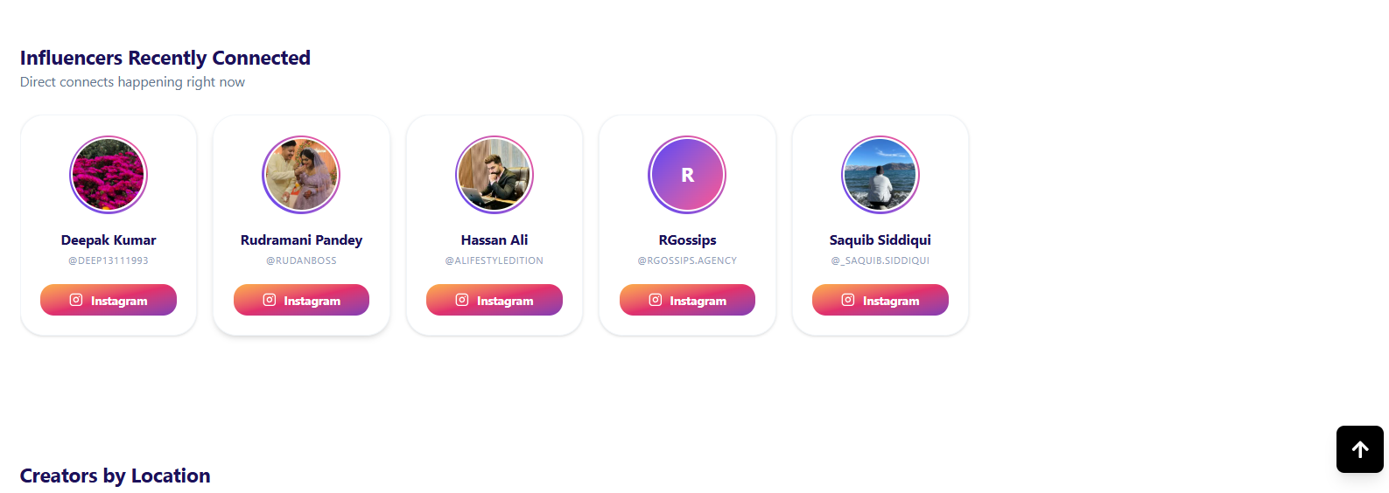

3. The top 2 sections “Creator by categories” and “Top Creators” are written in the same font style. Rest all the headings below that are of different style and size. Fix all the below ones as these Top 2.
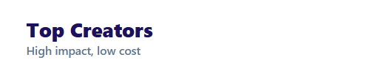

4. Ask Claude to fix the colour branding of this whole page with this header section. Like you can see that “Post Requirement Button” and the highlighted “Explore” button and “Post Requirement” in the left-hand side menu bar.
Also, the “#” and home of creator collaborations” text can be written in the same gradient, to make the page look consistent.
